INTERACTION DESIGN
One main aim of interaction design is to reduce the negative aspects (e.g. frustration, annoyance) of the user experience while enhancing the positive ones (e.g. enjoyment, engagement). In essence, it is about developing interactive products that are easy, effective, and pleasurable to use from the users’ perspective. A central concern of interaction design is to develop interactive products that are usable. By this is generally meant easy to learn, effective to use, and providing an enjoyable user experience.
Interaction design, often abbreviated IxD, is:
The design of interactive products and services in which a designer’s focus goes beyond the item in development to include the way users will interact with it. Thus, close scrutiny of users’ needs, limitations and contexts, etc. empowers designers to customize output to suit precise demands.
Put another way, it is about creating user experiences that enhance and augment the way people work, communicate, and interact. A number of terms have been used to emphasize different aspects of what is being designed, including user interface design, software design, user-centered design, product design, web design, experience design, and interactive system design. Interaction design is increasingly being accepted as the umbrella term, covering all of these aspects.
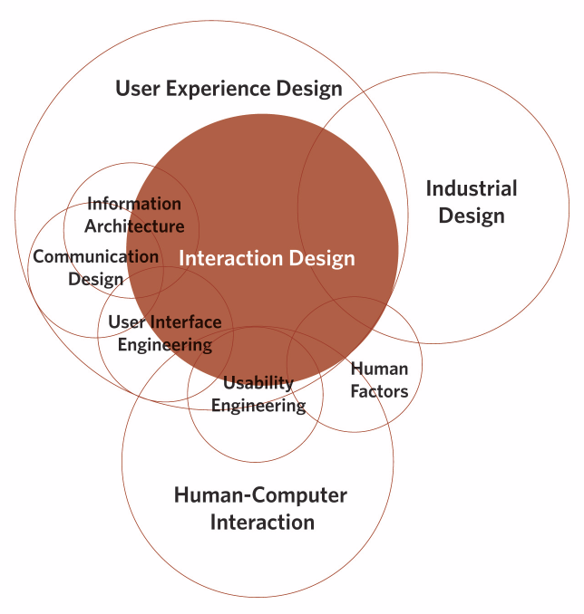

- User-centred design (UCD) - User-centered design (UCD) is an iterative design process in which designers focus on the users and their needs in each phase of the design process. In UCD, design teams involve users throughout the design process via a variety of research and design techniques, to create highly usable and accessible products for them.
- User interface design (UI) - User interface design or user interface engineering is the design of user interfaces for machines and software, such as computers, home appliances, mobile devices, and other electronic devices, with the focus on maximizing the user experience. The goal of user interface design is to make the user's interaction as simple and efficient as possible, in terms of accomplishing user goals (user-centered design).
- User Experience Design (UXD or UED or XD or UX) - User Experience Design is the process of enhancing user satisfaction by improving the usability, accessibility, and pleasure provided in the interaction between the user and the product. User experience design encompasses traditional human–computer interaction (HCI) design, and extends it by addressing all aspects of a product or service as perceived by users.
DIMENSION OF INTERACTION DESIGN
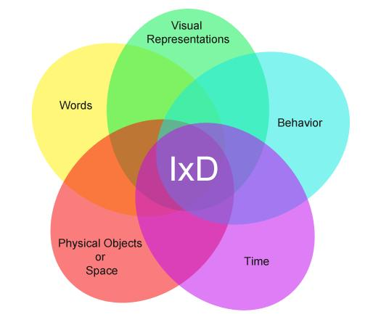
- 1D:Words -This dimension represents the semantics, or meaning, and the nature of a user’s interactions. Words are powerful, as we are capable of processing them quickly, implicitly and yet they influence us profoundly. A single word carries considerable meaning, and words are open to interpretation. For this reason, the terminology we use must be familiar to our intended users, accurately represent the actions they denote, conveyed in a tone that is appropriate for the setting, and used consistently throughout the product.
- 2D: Visual representations – This dimension refers to the elements that are not words within a product, such as the typography, diagrams, icons, and other graphics. These elements are no less powerful than words, as we are capable of processing imagery just as quickly and extracting meaning within a split second. visual representations are now commonplace in user interfaces, and we have already stored thousands of these elements in long-term memory, which allows us to interpret displays – when the design permits – immediately to the benefit of user experience. Four examples where visual representations have been employed are: icons, foreground/background colour distinctions, borders, and the use of visual hierarchies.
- 3D: Physical objects or space – refers to the actual hardware and objects that a user interacts with. For example, a computer keyboard, mouse, touchscreen, joystick, games controller, and keypad etc.
- 4D: Time - refers to how users might measure progress, with sound and animation for example, as well as how long they spend interacting with the first three dimensions.
- 5D: Behavior - Behaviour defines how users respond to the interface. Users may have different reactions in this interface.

USABILITY
The goal of interaction design is to design for maximum usability. Usability is all about producing things which are usable. Where something is usable when it meets these usability goals, however you should work out which goals are most important for the problem and focus on those first.
Definition of Usability:
Usability is a measure of the effectiveness, efficiency and satisfaction with which specified users can achieve specified goals in a particular environment.

Usability Goals (Pragmatic Goals)
Preece, Rogers and Sharp (Interaction Design) propose 6 usability goals:
- Effective
- Efficient
- Utility
- Learnable
- Memorable
- Safe
- Effective - Effectiveness is an overall measure of how well the system performs. “Can users use the system to do the work they need to do?”
- Efficiency - Efficiency is more akin to usable and can refer to the time required to use the interface and the likelihood of making errors using the system. ” Can experience users be productive using the system?”
- Utility - Utility is a measure of the correct functionality and breadth of functionality. Most good software is driven by utility, for example word processors have nearly all the features required to compose and format text documents. “Does the system provide all the functionality that users needs?”
- Learnable - Because the computer is a new tool and HCI a new discipline, learnable has been a concern of UI designers. Designers have been plagued with trying to design "familiar and natural interfaces" that can be learned without reading a manual. But learnable depends on functionality; not all interfaces should be expected to be usable without studying. A question that designers can ask, “Can users figure out what to do by exploring the interface?”
- Memorable - Memorable is how easy is it to remember how to use an interface after the user has experience with the system. Memorable is related to learnability and has generated GUIs with menus and icons, but the menu names and icons images need to be appropriate for them to be memorable. “What kind of support does the system have for remembering how to do tasks, especially infrequent tasks?”
- Safety – Safety is protecting the users from dangerous errors, for example losing all the user’s data or protecting the user’s confidential information. Safety can also refer to how users recover from errors. Safety is a little considered usability goal. An example of designing by safety is not putting the delete button next to the save button. Another example, is providing users various ways to recover from errors, both by reverting to a priority state or progressing the system to the correct state. For example in a word processor, the write can use control-z to correct, back button, or retype to correct mistakes. “What kind of errors can users make and how can they recover from the mistake?”

USER EXPERIENCE GOALS
User Experience (UX) is an idea of creating products or services with the deep focus on users needs, limitations, and skills. The interface should provide the following user experience goals:
- Satisfying
- Enjoyable
- Fun
- Entertaining
- Helpful
- Motivating
- Aesthetic
- Supports creativity
- Rewarding
- Emotionally fulfilling
- Enjoyable - At least we do not want the app to be frustrating.
- Helpful - Especially are apps are meant to be helpful.
- Motivating - we want users (which might not really want to be on the field trip) to use the app
- Support Creativity - Although our apps constrain the user to performing the task correctly, we hope that users will feel creative during the pursuit of data while recording the data.
- Rewarding - Rewarding will ensure that users continue using, how can reward the user?

USABILITY DESIGN PRINCIPLES AND RULES
Jakob Nielsen’s 10 Usability Heuristics
"The 10 most general principles for interaction design. They are called 'heuristics' because they are more in the nature of rules of thumb than specific usability guidelines.". They were developed by Jakob Nielsen together with Rolf Molich in the early 90's. The final set below was released by Nielsen in 1994.
- Visibility of system status: the system should always keep users informed about what is going on, through appropriate feedback within reasonable time.
- Match between system and the real world: the system should speak the users' language, with words, phrases and concepts familiar to the user, rather than system oriented terms. Follow real-world conventions, making information appear in a natural and logical order.
- User control and freedom: users often choose system functions by mistake and will need a clearly marked "emergency exit" to leave the unwanted state without having to go through an extended dialogue. Support undo and redo.
- Consistency and standards: users should not have to wonder whether different words, situations, or actions mean the same thing. Follow platform conventions.
- Error prevention: even better than good error messages is a careful design which prevents a problem from occurring in the first place. Either eliminate error-prone conditions or check for them and present users with a confirmation option before they commit to the action.
- Recognition rather than recall: Minimize the user's memory load by making objects, actions, and options visible. The user should not have to remember information from one part of the dialogue to another. Instructions for use of the system should be visible or easily retrievable whenever appropriate.
- Flexibility and efficiency of use: accelerators unseen by the novice user may often speed up the interaction for the expert user such that the system can cater to both inexperienced and experienced users. Allow users to tailor frequent actions.
- Aesthetic and minimalist design: dialogues should not contain information which is irrelevant or rarely needed. Every extra unit of information in a dialogue competes with the relevant units of information and diminishes their relative visibility.
- Help users recognize, diagnose, and recover from errors: error messages should be expressed in plain language (no codes), precisely indicate the problem, and constructively suggest a solution.
- Help and documentation: even though it is better if the system can be used without documentation, it may be necessary to provide help and documentation. Any such information should be easy to search, focused on the user's task, list concrete steps to be carried out, and not be too large.

Ben Shneiderman's 8 Golden Rules
To improve the usability of an application it is important to have a well designed interface. Shneiderman's "Eight Golden Rules of Interface Design" are a guide to good interaction design.
- Strive for consistency - Consistent sequences of actions should be required in similar situations; identical terminology should be used in prompts, menus, and help screens; and consistent commands should be employed throughout.
- Enable frequent users to use shortcuts - As the frequency of use increases, so do the user's desires to reduce the number of interactions and to increase the pace of interaction. Abbreviations, function keys, hidden commands, and macro facilities are very helpful to an expert user.
- Offer informative feedback - For every operator action, there should be some system feedback. For frequent and minor actions, the response can be modest, while for infrequent and major actions, the response should be more substantial.
- Design dialog to yield closure - Sequences of actions should be organized into groups with a beginning, middle, and end. The informative feedback at the completion of a group of actions gives the operators the satisfaction of accomplishment, a sense of relief, the signal to drop contingency plans and options from their minds, and an indication that the way is clear to prepare for the next group of actions.
- Offer simple error handling - As much as possible, design the system so the user cannot make a serious error. If an error is made, the system should be able to detect the error and offer simple, comprehensible mechanisms for handling the error.
- Permit easy reversal of actions - This feature relieves anxiety, since the user knows that errors can be undone; it thus encourages exploration of unfamiliar options. The units of reversibility may be a single action, a data entry, or a complete group of actions.
- Support internal locus of control - Experienced operators strongly desire the sense that they are in charge of the system and that the system responds to their actions. Design the system to make users the initiators of actions rather than the responders.
- Reduce short-term memory load - The limitation of human information processing in short-term memory requires that displays be kept simple, multiple page displays be consolidated, window-motion frequency be reduced, and sufficient training time be allotted for codes, mnemonics, and sequences of actions.

Don Norman's Principles of interaction Design
- Visibility – The more visible functions are, the more likely users will be able to know what to do next. In contrast, when functions are "out of sight," it makes them more difficult to find and know how to use.
- Feedback – Feedback is about sending back information about what action has been done and what has been accomplished, allowing the person to continue with the activity. Various kinds of feedback are available for interaction design-audio, tactile, verbal, and combinations of these.
- Constraints – The design concept of constraining refers to determining ways of restricting the kind of user interaction that can take place at a given moment. There are various ways this can be achieved.
- Mapping – This refers to the relationship between controls and their effects in the world. Nearly all artifacts need some kind of mapping between controls and effects, whether it is a flashlight, car, power plant, or cockpit. An example of a good mapping between control and effect is the up and down arrows used to represent the up and down movement of the cursor, respectively, on a computer keyboard.
- Consistency – This refers to designing interfaces to have similar operations and use similar elements for achieving similar tasks. In particular, a consistent interface is one that follows rules, such as using the same operation to select all objects. For example, a consistent operation is using the same input action to highlight any graphical object at the interface, such as always clicking the left mouse button. Inconsistent interfaces, on the other hand, allow exceptions to a rule.
- Affordance – is a term used to refer to an attribute of an object that allows people to know how to use it. For example, a mouse button invites pushing (in so doing acting clicking) by the way it is physically constrained in its plastic shell. At a very simple level, to afford means "to give a clue" (Norman, 1988). When the affordances of a physical object are perceptually obvious it is easy to know how to interact with it.

